**Products Queries**

**Create DataBase productDB:**

Create Collection “products”:



Inserted data for the products collection from productsDB.txt file

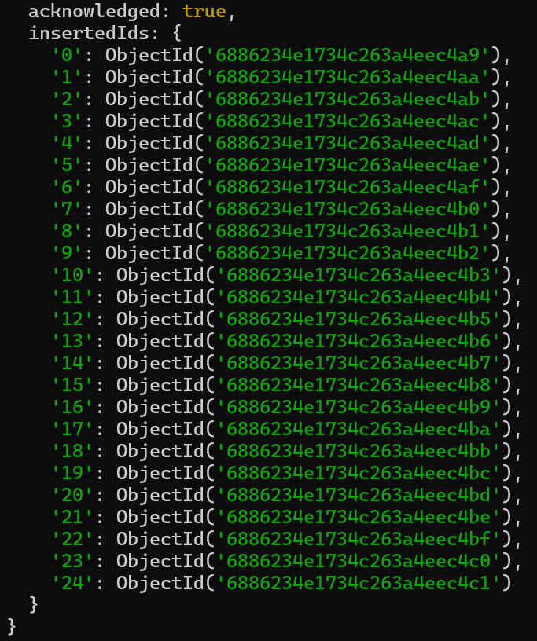

**Query 1:Find all the information about each product**

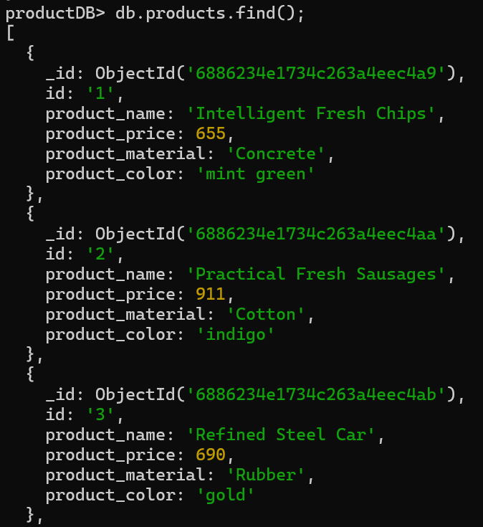

**Query 2:Find the products with price between 400 to 800**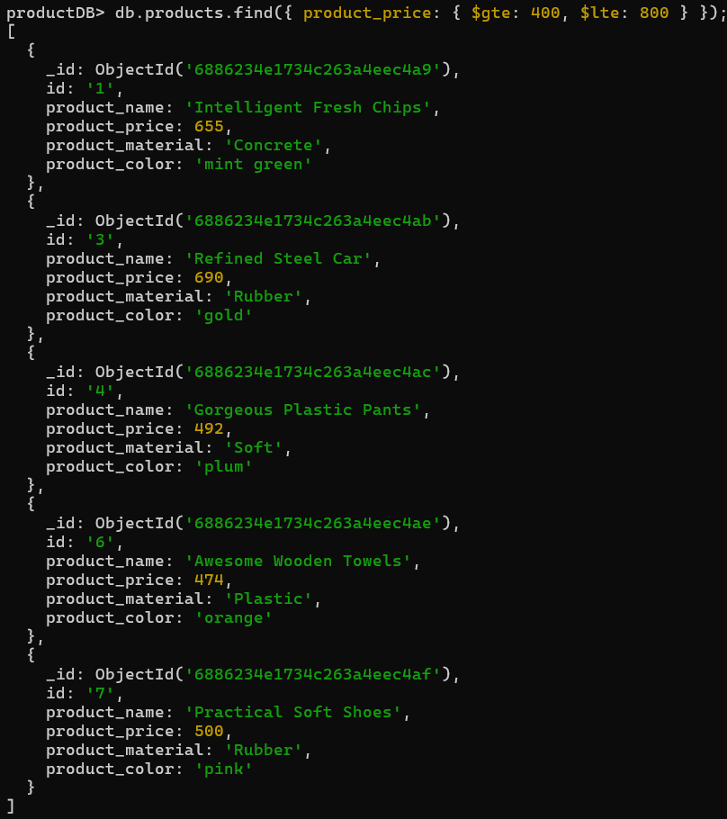

**Query 3:Find the products with price not between 400 to 600**

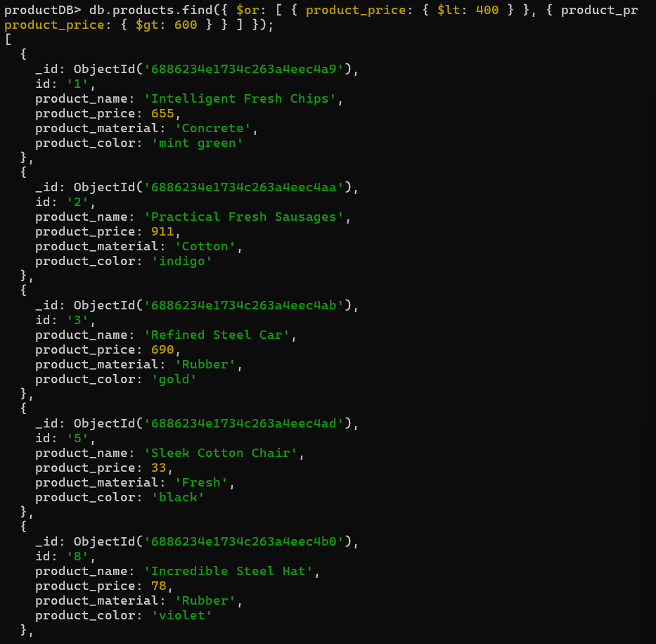

**Query 4:List the four products with price greater than 500**

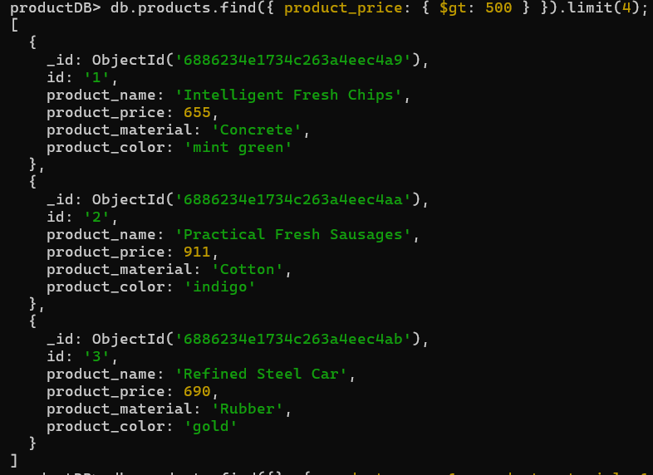

**Query 5:Find product name and product material of each product**

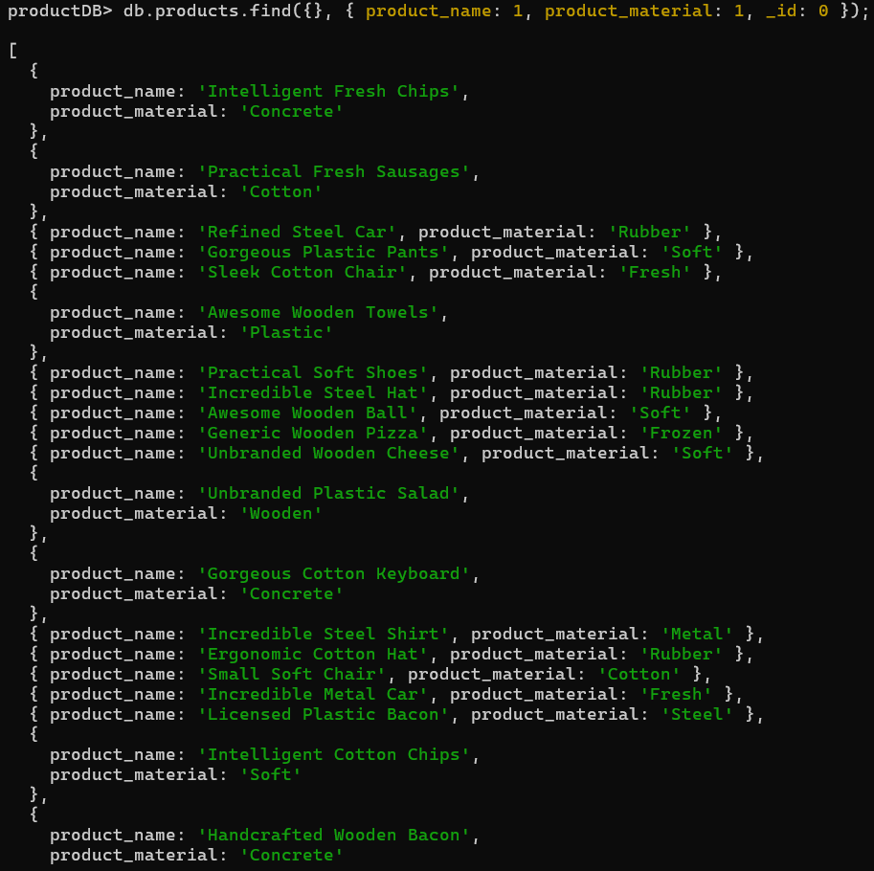

**Query 6:Find the product with a row id of 10**

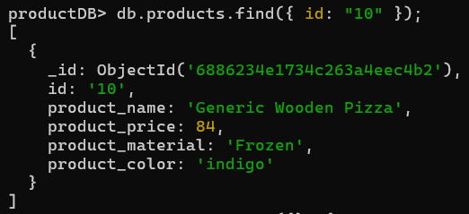

**Query 7: Find only the product name and product material**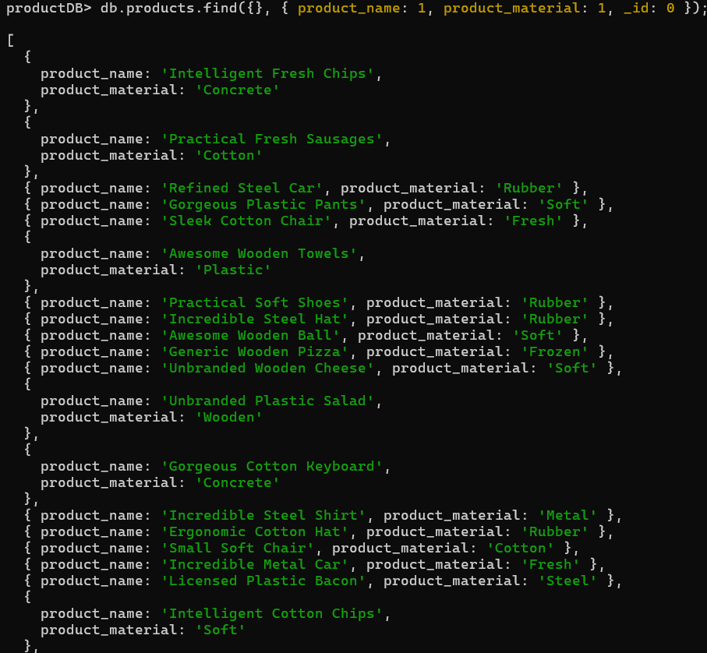

**Query 8:Find all products with “soft” in product material**

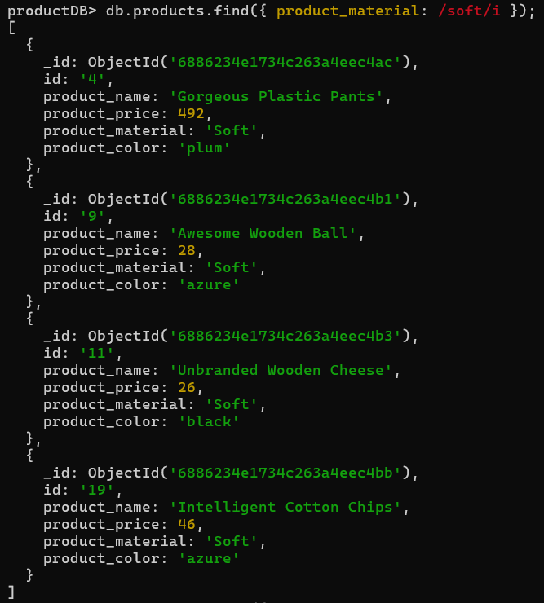

**Query 9:Find products with color "indigo" and price 492.00**

**Query 10: Delete products where product price values are same**

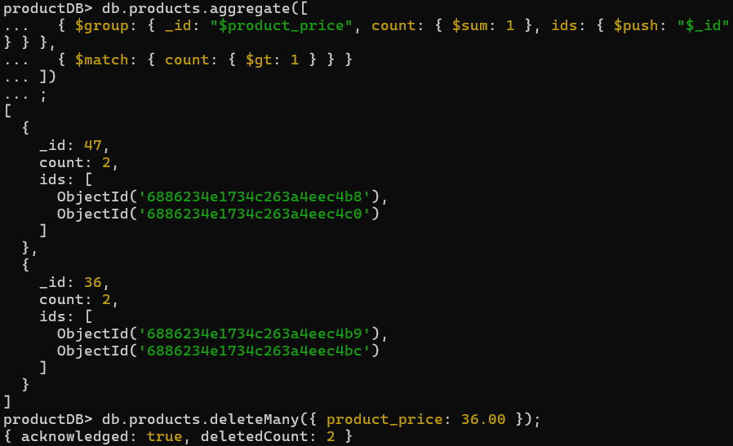

**Conclusion:**

This project demonstrated how to use MongoDB to efficiently manage and query product data. We explored key operators like $gte,$lte,$or, and regex to filter, retrieve, and clean data. Through these queries, we gained hands-on experience with MongoDB's powerful features for handling unstructured data, enhancing our practical skills in NoSQL database operations.